THE WITCH’S WISHES

- If two witches were watching two watches, which witch would watch which watch?
- Which watches are the witches’ watches?
- She washes and washes and washes the dishes; meanwhile, she wishes for smooches.
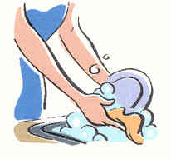
- Which Swiss witch switched the Swiss wristwatches?
- He squishes and squashes and squooshes the galoshes, and then thrashes the toothbrushes. What a mess!
- See how she distinguishes dogfishes from bullfinches.
- The broaches were returned, so the charges were dropped.
- She blushes and scratches her itches, and then she clenches her breeches and screeches – meanwhile, a flock of ostriches emerges from the trenches.
- She brushes and brushes and blushes and blushes, but her eyelashes are still as big as rosebushes.

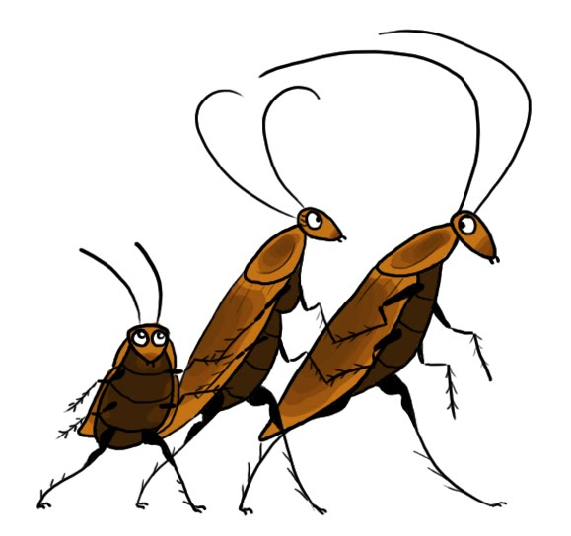

- As he approaches the benches, he suddenly sees avalanches of cockroaches.
- She shushes the pooches, and then banishes the dervishes.

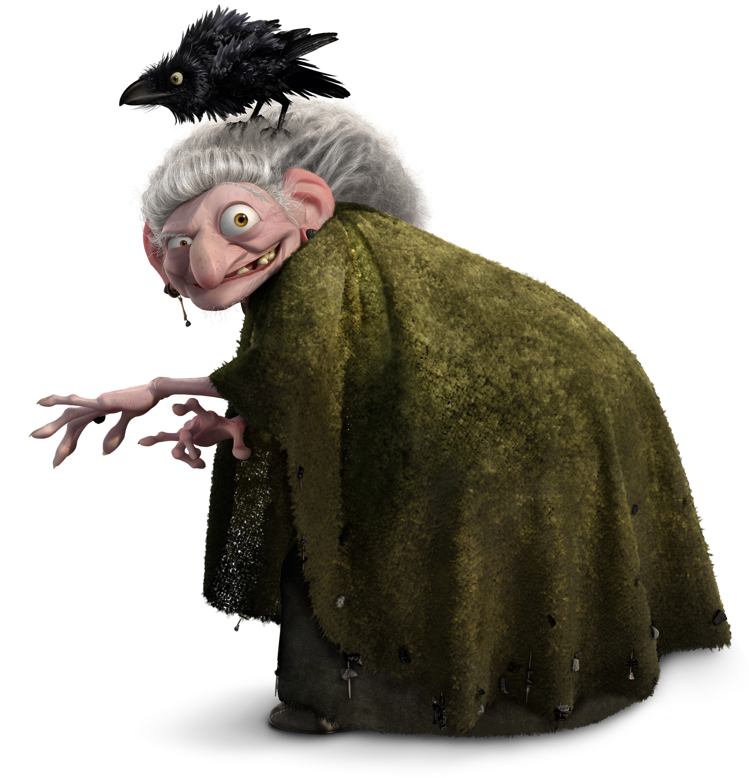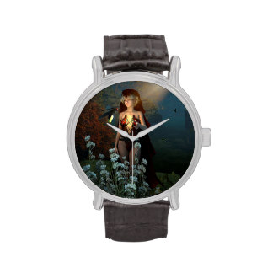
What are the witch’s wishes? And where are her watches?

But what about the witch’s clothes?

"Clothes" is pronounced "Cloathz", with the "oa" sound of "goat", and the "th" of "they". When said at a quick, conversational pace, it sounds closer to "close"; the "th" is very lightly pronounced. But when said slower, the "th" sound is distinct and followed by the "z" sound.

After she washes them, the witch smoothes her clothes, stitches some patches on them and stacks them in her wardrobe. Then she bathes her six little kids and soothes their brows. After that, she reclothes them and sends them off to bed. Meanwhile, the witch’s husband clenches his jaw and seethes and seethes – he loathes this evening ritual.

Read these sentences.
- I had six stitches on my lip.
- Two foxes are on a rabbit hunt.
- I put my dresses in the box.
- That bee buzzes a lot.
- I got six candy kisses.
- How many kisses did you get?
- How many boxes do you want?
- The buses are here!
- My mom pushes me when I swing.
- I have two witches on my lunch bag.
- Put the brushes in the sink.
- My dog fetches the things I toss.
- My dog rushes to the bus.
- I lost my glasses!
- I have two addresses.
- I will add the taxes to the bill.

